On php Migrations

The idea behind migrations is really a ‘modular’, ‘snippet’ ‘addon’ way of managing databases.

When you create a database schema you define the collumns for it schema::create.

This is effectively a ‘plan’ or ‘recipe’ for the table.

When we want to ‘change’ the database, we create a new migration file. (must have a different name, describing the change). We must also indicate the ‘table’ the migration applies to, so we can save some boilerplate code:



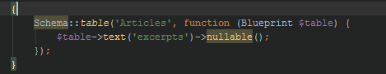

In this boilerplate we can put in ‘modifications’.

When we migrate the database it chronologically applies all the ‘migrations’, to ‘create’ the database as it goes to it’s current state.

(kind of like evo-devo in evoloution).

Use php artisan migrate:rollback to roll the database to the current version -1.